**Part A: Getting Started**

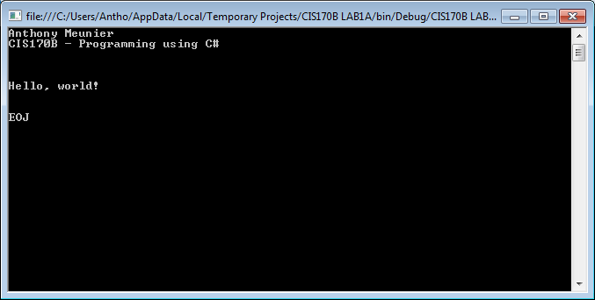

class Hello

{

static void Main()

{

// display output

System.Console.WriteLine("Anthony Meunier");

System.Console.WriteLine("CIS170B - Programming using C#");

System.Console.WriteLine("\n\n\nHello, world!\n\n");

System.Console.WriteLine("EOJ");

System.Console.ReadLine();

}

}

**Part B: Calculate Total Tickets**

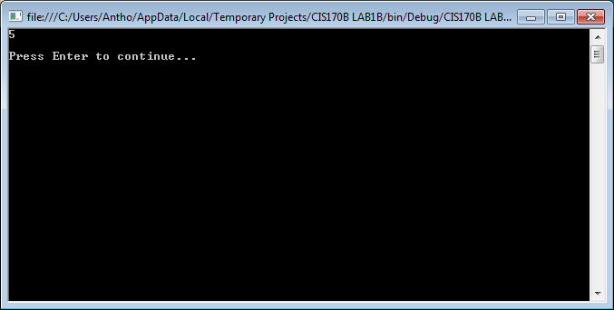

// ---------------------------------------------------------------

// Programming Assignment: LAB1B

// Developer: Anthony Meunier

// Date Written: 7/13/2014

// Purpose: Ticket Calculation Program

// ---------------------------------------------------------------

using System;

class FirstOutputWithUsing

{

static void Main()

{

// create variables and load values

int childTkts, adultTkts, totalTkts;

childTkts = 3;

adultTkts = 2;

// process (calculation)

totalTkts = childTkts + adultTkts;

// display output

Console.WriteLine(totalTkts);

// pause

Console.Write("\nPress Enter to continue...");

Console.ReadLine();

}

}

**Part C: Payroll Program**

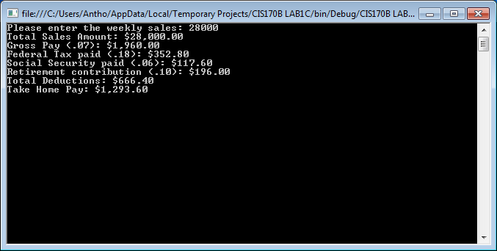

// ---------------------------------------------------------------

// Programming Assignment: LAB1C

// Developer: Anthony Meunier

// Date Written: 7/13/2014

// Purpose: Payroll Program

// ---------------------------------------------------------------

using System;

using System.Collections.Generic;

using System.Linq;

using System.Text;

using System.Threading.Tasks;

namespace CIS170B_LAB1C

{

class Program

{

static void Main(string[] args)

{

//declare variables

double weeklySales, grossPay, fedTax, socSecurity, retirement, totDeductions, takeHomePay;

//get the input

Console.Write("Please enter the weekly sales: ");

weeklySales = Convert.ToDouble(Console.ReadLine());

//do the calculations

grossPay = weeklySales * .07;

fedTax = grossPay * .18;

socSecurity = grossPay * .06;

retirement = grossPay * .1;

totDeductions = fedTax + socSecurity + retirement;

takeHomePay = grossPay - totDeductions;

//display the output

Console.WriteLine("Total Sales Amount: {0:C}", weeklySales);

Console.WriteLine("Gross Pay (.07): {0:C}", grossPay);

Console.WriteLine("Federal Tax paid (.18): {0:C}", fedTax);

Console.WriteLine("Social Security paid (.06): {0:C}", socSecurity);

Console.WriteLine("Retirement contribution (.10): {0:C}", retirement);

Console.WriteLine("Total Deductions: {0:C}", totDeductions);

Console.WriteLine("Take Home Pay: {0:C}", takeHomePay);

//keep the console display open

Console.ReadLine();

}

}

}